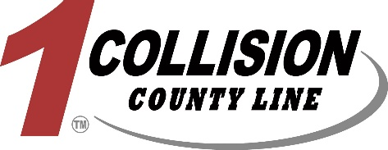

Auto Body Painter

Join us and be part of a fast growing, family-owned business passionate about high quality repairs and exceptional customer service. With over 40 years in the industry, our business continues to grow and be one the strongest independent collision repair facilities in the Milwaukee area. We are looking for an auto body painter that is dependable, efficient, and has high quality refinishing standards. Our company is growing in sales (double digit % growth year over year) and the income opportunity for this position is unlimited.
We are currently using AkzoNobel/Sikkens solvent-based paint materials
Benefits
- Competitive pay
- 401K
- Medical/Vision/Dental Insurance
- Paid Vacation/PTO
- Flexible schedule
Qualifications
- Education and Experience - Completion of high school or equivalent and 5-plus years of automotive painting experience preferred
Responsibilities
- Painter is responsible for surface preparation, masking, color matching, painting and buffing if needed
- Painter will be working alongside second painter; opportunity for working together or during different shifts for maximum efficiency and earning potential
Pay
- $20-$30 flat rate

